**Project Name: Advance e-commerce**

Group members:

|  |  |  |  |  |
| --- | --- | --- | --- | --- |
| sr | Name | Id | Email | Phone |
| 1 | Borno, Md. Sirajuddin | 18-36449-1 | [bornoahmed2@gmail.com](mailto:bornoahmed2@gmail.com) | 01704992725 |
| 2 | Hossain, Muntasir | 18-36421-1 | [muntasirhosain@gmail.com](mailto:muntasirhosain@gmail.com) | 01788075438 |
| 3 | Abdullah, Syed | 18-36537-1 | [syed_khoab@outlook.com](mailto:syed_khoab@outlook.com) | 01744-641522 |
| 4 | Faisal, Mahbub Hossain | 18-37337-1 | [mahbubhossain249@gmail.com](mailto:mahbubhossain249@gmail.com) | 01966272734 |

1. **Introduction**
   1. **Purpose:** Mainly in Dhaka city where people are doing their job and can’t find enough time to go to the grocery store every week to buy their groceries. Who goes shopping most of the time goes without a proper shopping list and spends more than their need. That’s why we are offering a smart web service that can suggest them make a proper shopping list based on 3 parameters. (i) Number of a family member, (ii) Monthly budget, (iii) Based on previous shopping stats. Customers can always edit the suggestion based on their needs. Then customers can order those products online. We will deliver products weekly. The best part is customers can make payments monthly and they can choose a specific time limit on a specific day of the week when s/he wants the delivery (e.g. 7 pm-9 pm, Monday). This way customers can save time and save themselves from overspending.
   2. **Document Convention:**

Font family: Calibri (Body)

Font size: 12

Font color: Gray 80%, text 1, lighter 25%

* 1. **Project Scope:** The scope of this project is to study and design a web application that will provide services to the busy families. Deliver products within fixed days of weeks and in a time range. Deliver fresh vegetables and groceries regularly.
  2. **References:**

1. <https://www.daraz.com.bd/>

2. <https://evaly.com.bd/>

3. <https://dhamakashopping.com/>

4. <https://www.foodpanda.com.bd/>

1. **Overall Description**
   1. **Productive perspective:** Design a website for e-commerce where retailer will show products and customers will buy them. Customers will order products and delivery man will bring the products to the customers. This web application will sale products and services but in bit different way. This application will have several users.
   2. **User classes and characteristics:**

|  |  |
| --- | --- |
| User Class | Characteristics |
| Admin | Register new Admin or Managers. Monitor business stats and make business deals. |
| Managers | HR manager to verify new delivery mans and new retailers. They also manage their deals.  Accounting and Finance Manager to handle money flow of the business. They also monitor whole market place and where to invest, what offer to run for promotions. |
| Tech support | Tech Support team develop and maintain website and mobile application. Provide updates and upgrades. |
| Customer | Customers will buy services and products from this business. |
| Delivery man | Deliver man will deliver products to customers. |
| Retailer | Retailers will provide products to be delivered. |
|  |  |
|  |  |
|  |  |

* 1. **Operating Environment:** This system will be developed on Windows10 based Desktops. There will be a web application to run on all platforms and mobile application Android and IOS will be developed in future.
  2. **Design and implementation constraints:** To design this website ASP.NET framework will be used. Programing Language is C# to develop backend, for database MS SQL server will be used. For front end a JS framework React, bootstrap, CSS, HTML will be used.

Version:

|  |  |
| --- | --- |
| Application and API | version |
| Visual Studio | 2019 |
| ASP.NET framework | 4.5 |
| MS SQL Server | 18.8 |
| HTML | 5 |
| CSS | 3 |
| Bootstrap | 4 |
| React JS | 17.0.2 |

1. **System Features**
   1. **Description of feature:**

**Admin:**

1. Login
2. Add new admin and managers
3. View Retailer and delivery man information
4. View customer information

**HR Manager:**

1. Login
2. Retailer verification
3. Delivery man verification

**Accounting and Finance:**

1. Login
2. Manage Income and expenditure

**Customer:**

1. Self-Registration
2. Login
3. Customer Info

* Add Monthly Income
* Number of family members (specify adult and children)
* Monthly expenditure on grocery (range of amount)*
* Address
* Number of delivery in a month (2/4 per month)
* Number of delivery for Vegetables/Fruits (2-3 in a week)
* Preferable delivery day and time*

      3. View product

* By shop
* By category
* Search
* Sort
* Suggestion List*

        4. Add to cart

      5. Checkout

      6. Make payment (Mobile banking, Card)*

      7. View balance

      8.   Service cancelation (Entirely)

      9. Order Cancelation (Weekly/Monthly)

     10.  Feedback on product and delivery service (optional)

     11.  Discounts/Voucher/Referrals

     12. View stats (Monthly, Category)

**Retailer:**

1. Self-Registration
2. Retailer info
   1. Shop name
   2. Shop Address
   3. Bank account information
   4. Verification
3. Add/Update/Disable Product
4. Discount/Voucher
5. View Review and ratings
6. Update delivery information

**Delivery Man:**

1. Self-Registration
2. Verification
3. Login
4. View nearest order
5. Accept order
6. Update delivery process
7. View Stats
8. View Review and ratings
   1. **Functional requirements**

3.2.1.The customers shall be able to login to the system “if they are not registered then the system shall provide a registration form for registration”.

3.2.2. The customer shall be able to get a suggestions of groceries based on their monthly expenditure “If they want to customize grocery list then the system shall provide e customization option”.

3.2.3. The customer shall be able to customize their cart product list before 24 hours.

3.2.4. The customer shall be able to order products “If they want to cancel order at any time the system shall provide an option to cancel the order”.

3.2.5. The customer shall be able to checkout order “If they don’t checkout before 24 hours then the system will done the order process automatically”.

3.2.6. The customer shall be able to select payment method from the system.

3.2.7. The customer shall be able to give rating and feedback to specific products.

3.2.8. The customer shall be able see the stats based on their history of purchases.

3.2.9. The customers shall be able to apply vouchers and discount on payment section.

3.2.10. The admin shall be able to register new admin or managers to the system.

3.2.11. The HR manager shall be able to verify new retailer and deliveryman.

3.2.12. The HR manager shall be able to see human resource management stats.

3.2.13. The accountant manager shall be able to manage Income and expenditure.

3.2.14. The retailer shop shall be able to register to the system.

3.2.15. The retailer shop shall be able to update products to the system.

3.2.16. The retailer shop shall be able to see review and ratings of their shop.

3.2.17. The retailer shop shall be able to update delivery information.

3.2.18. The retailer shop shall be able to add products to the site.

3.2.19. The deliveryman shall be able self-register himself to the system.

3.2.20. The delivery man shall be able to find order based on location.

3.2.21. The deliveryman shall be able to see and update the delivery status of order.

3.2.22. The delivery man shall be able see his/her ratings and reviews.

* 1. **User Stories (user requirements):**

|  |  |
| --- | --- |
| **Sample Use Case** | **Corresponding User Story** |
| Manager registration | As an Admin I want to register new manager so that they can maintain our system. |
| Verify retailer and delivery man | As a manager I want to verify Retailer and delivery man so that in future our system can track them and customer can get better service. |
| Customer Registration | As a customer I want to register my profile into this platform so that I can buy product. |
| Update customer profile | As a customer I want to update my profile so that future purchases are billed to updated information. |
| Order product and cancelation | As a customer I want to order product on my given information and if I don’t want to order then I will cancel my own. |
| Feedback on product and service | As a customer I want to give feedback on product and service so that in future another customer can take decision on purchasing. |
| Customer profile statistics | As a customer I want to view my daily/weekly/monthly statistics so that I can be updated. |
| Retailer Registration | As a retailer I want to register my account so that I can sell product. |
| Update Product | As a retailer I want to update, delete or insert new product into my shop to get customer and keep my shop status updated; |
| Review And Ratings | As a retailer I want to see my shop review that given by customer to solve what type of fault I have done. |
| Delivery Information | As a Retailer I want update delivery information so that customer can get updated about their product. |
| Delivery Man registration | As a delivery man I want create my account so that I can deliver product. |
| Find Order | As a delivery man I want to find customer order to deliver it properly. |
| Delivery Information | As a delivery man I want update delivery information so that customer can get updated about their product. |
| View Statistics | As a delivery man I want see how many delivery I have done. |
| Review And Ratings | As a delivery man I want to see my review that given by customer to solve what type of fault I have done. |

1. **External Interface Requirements**
   1. **User interface:**

**Home page:**

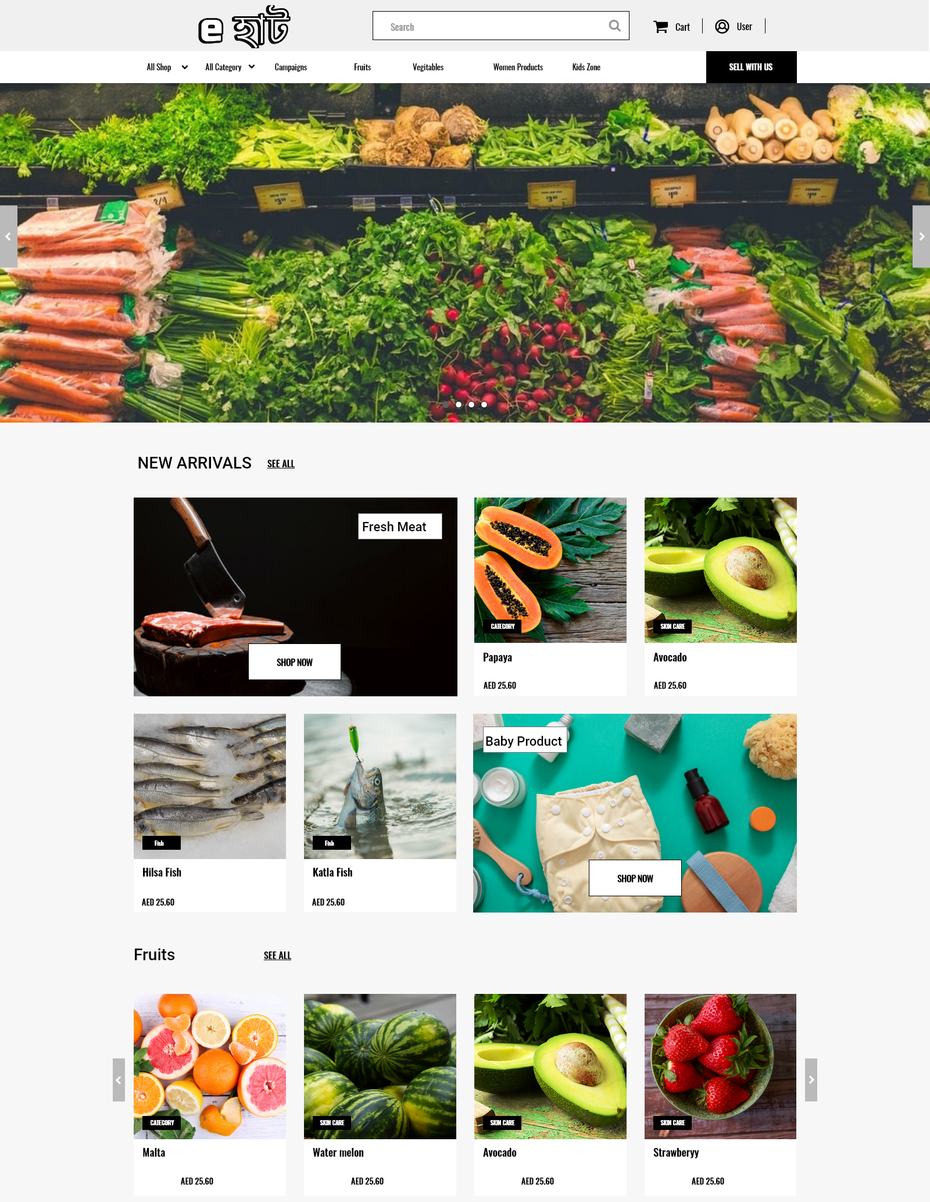

**Sign in/ registration**

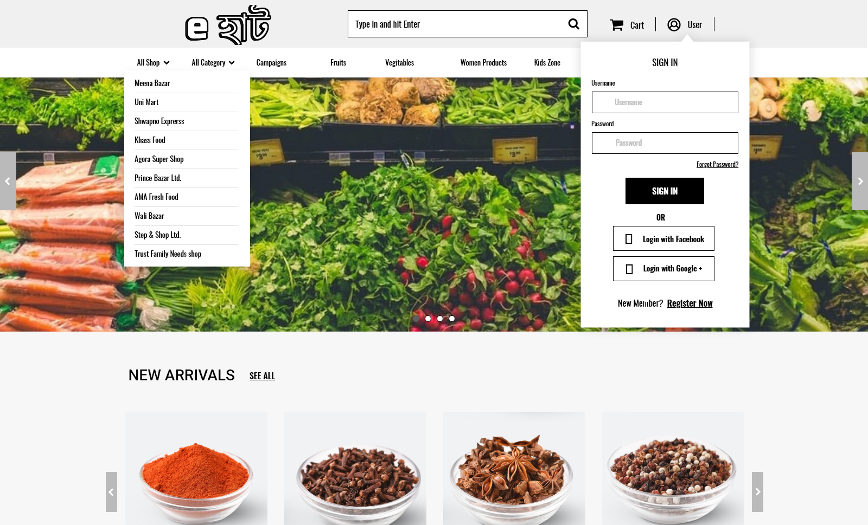

**Product Details**

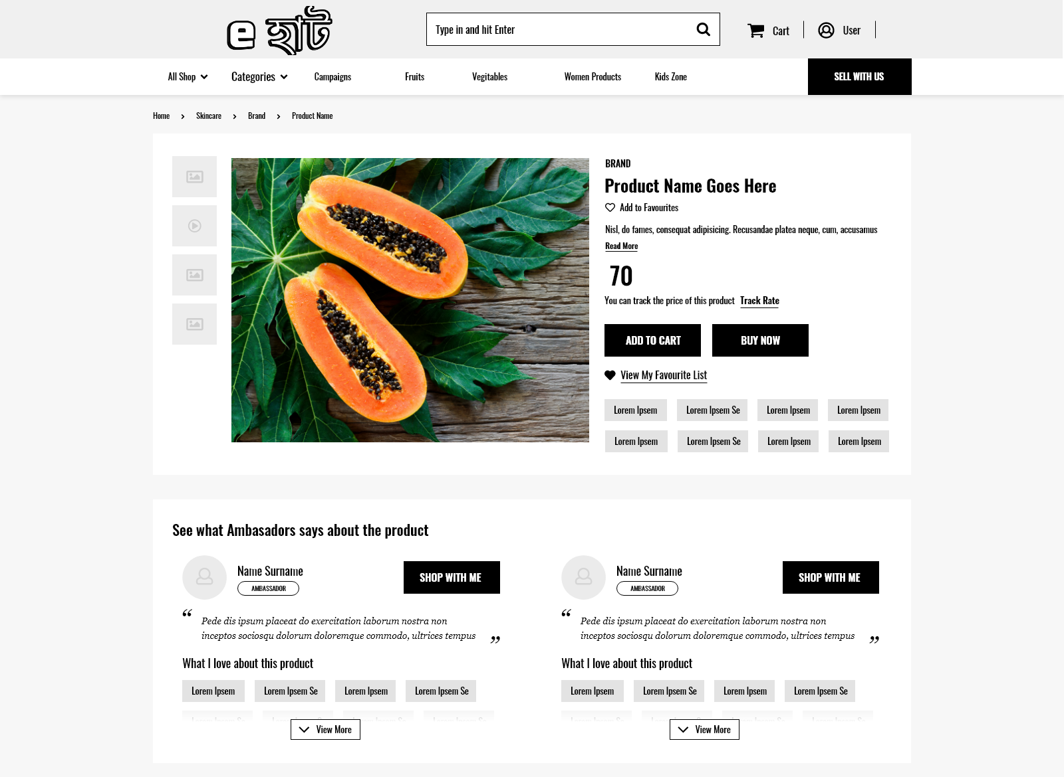

**Product review**

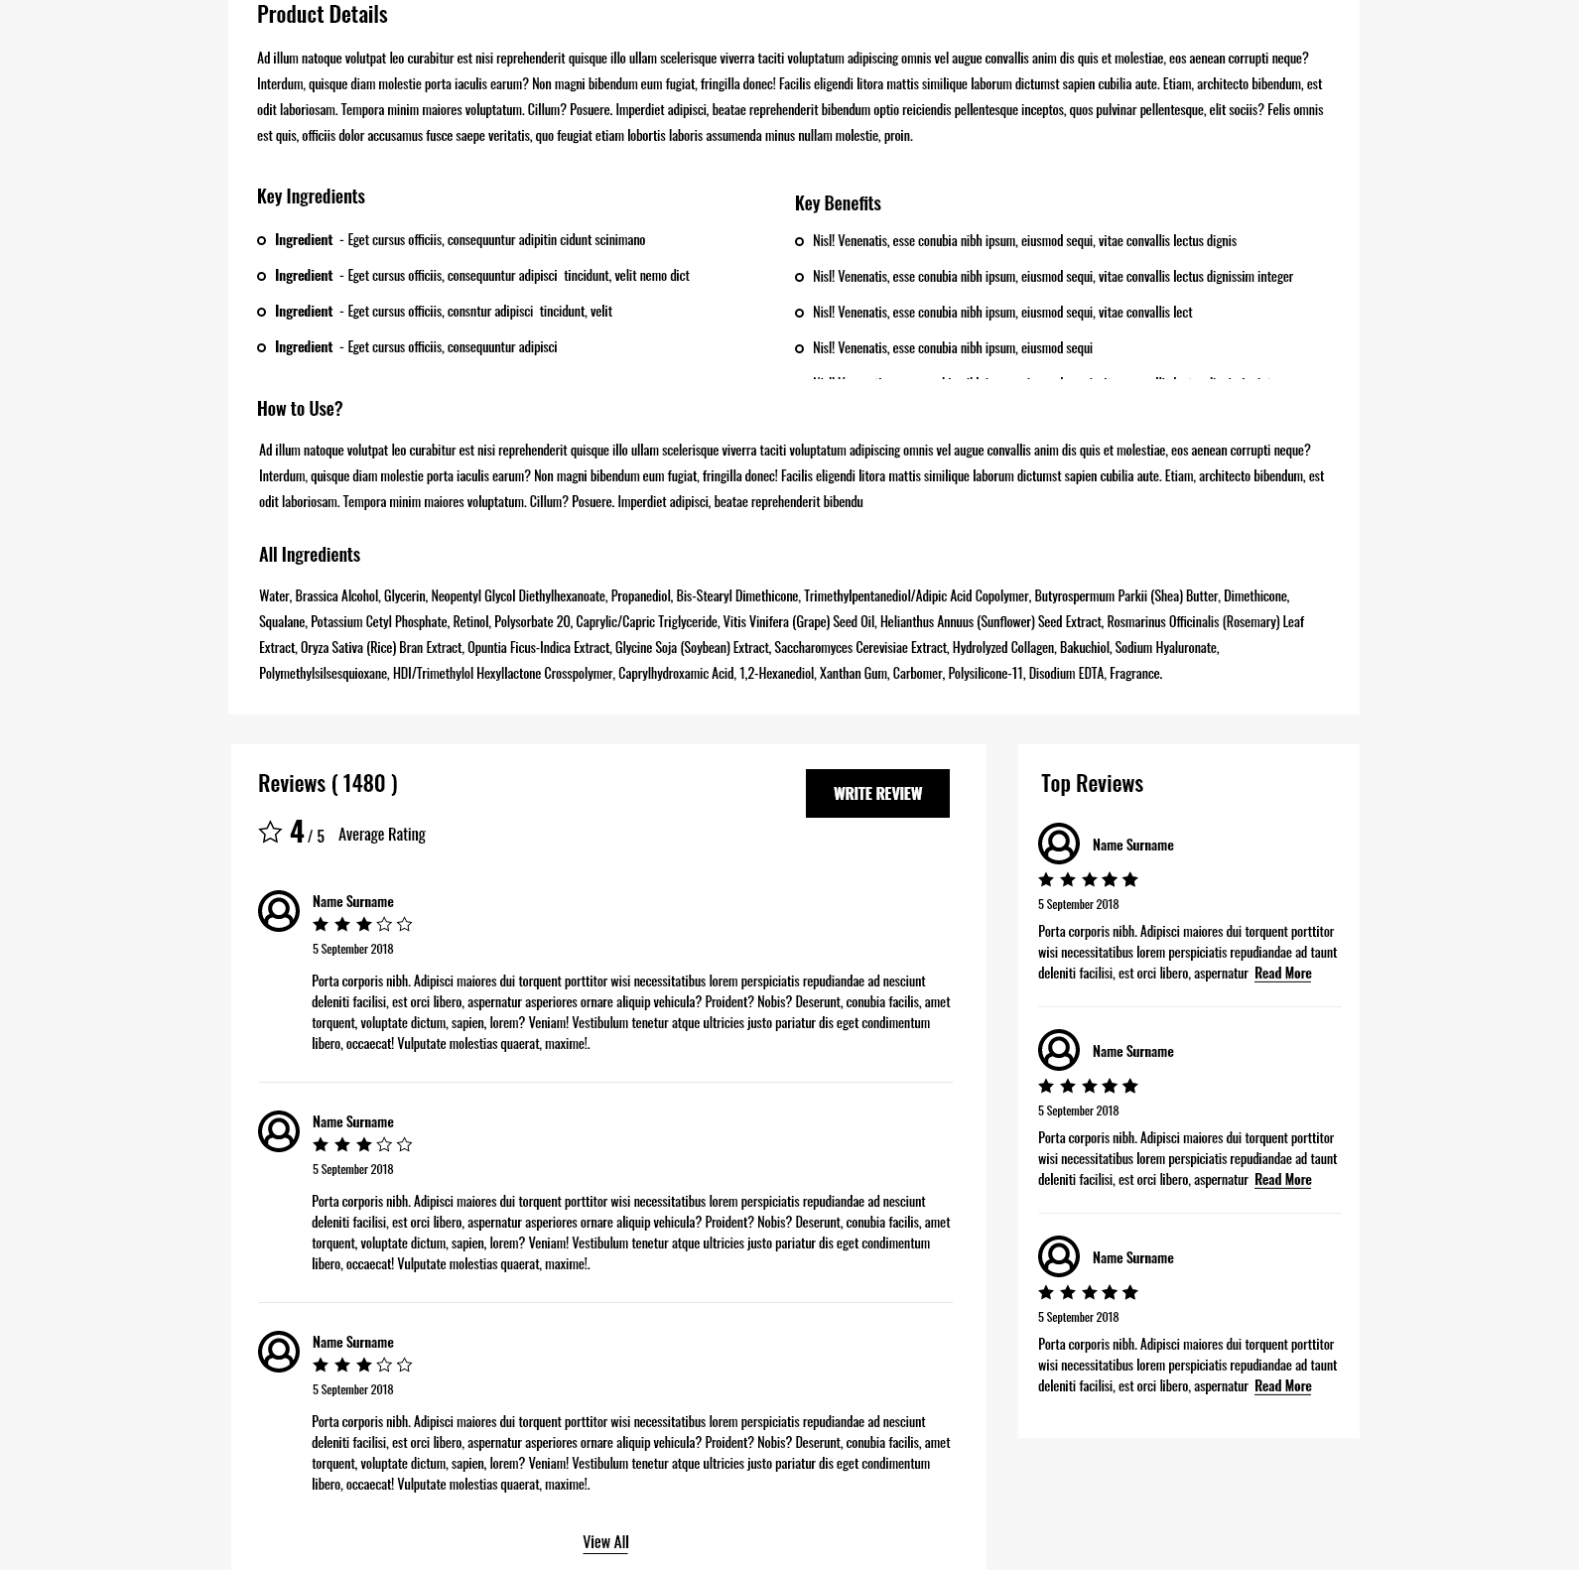

**Suggestion page**

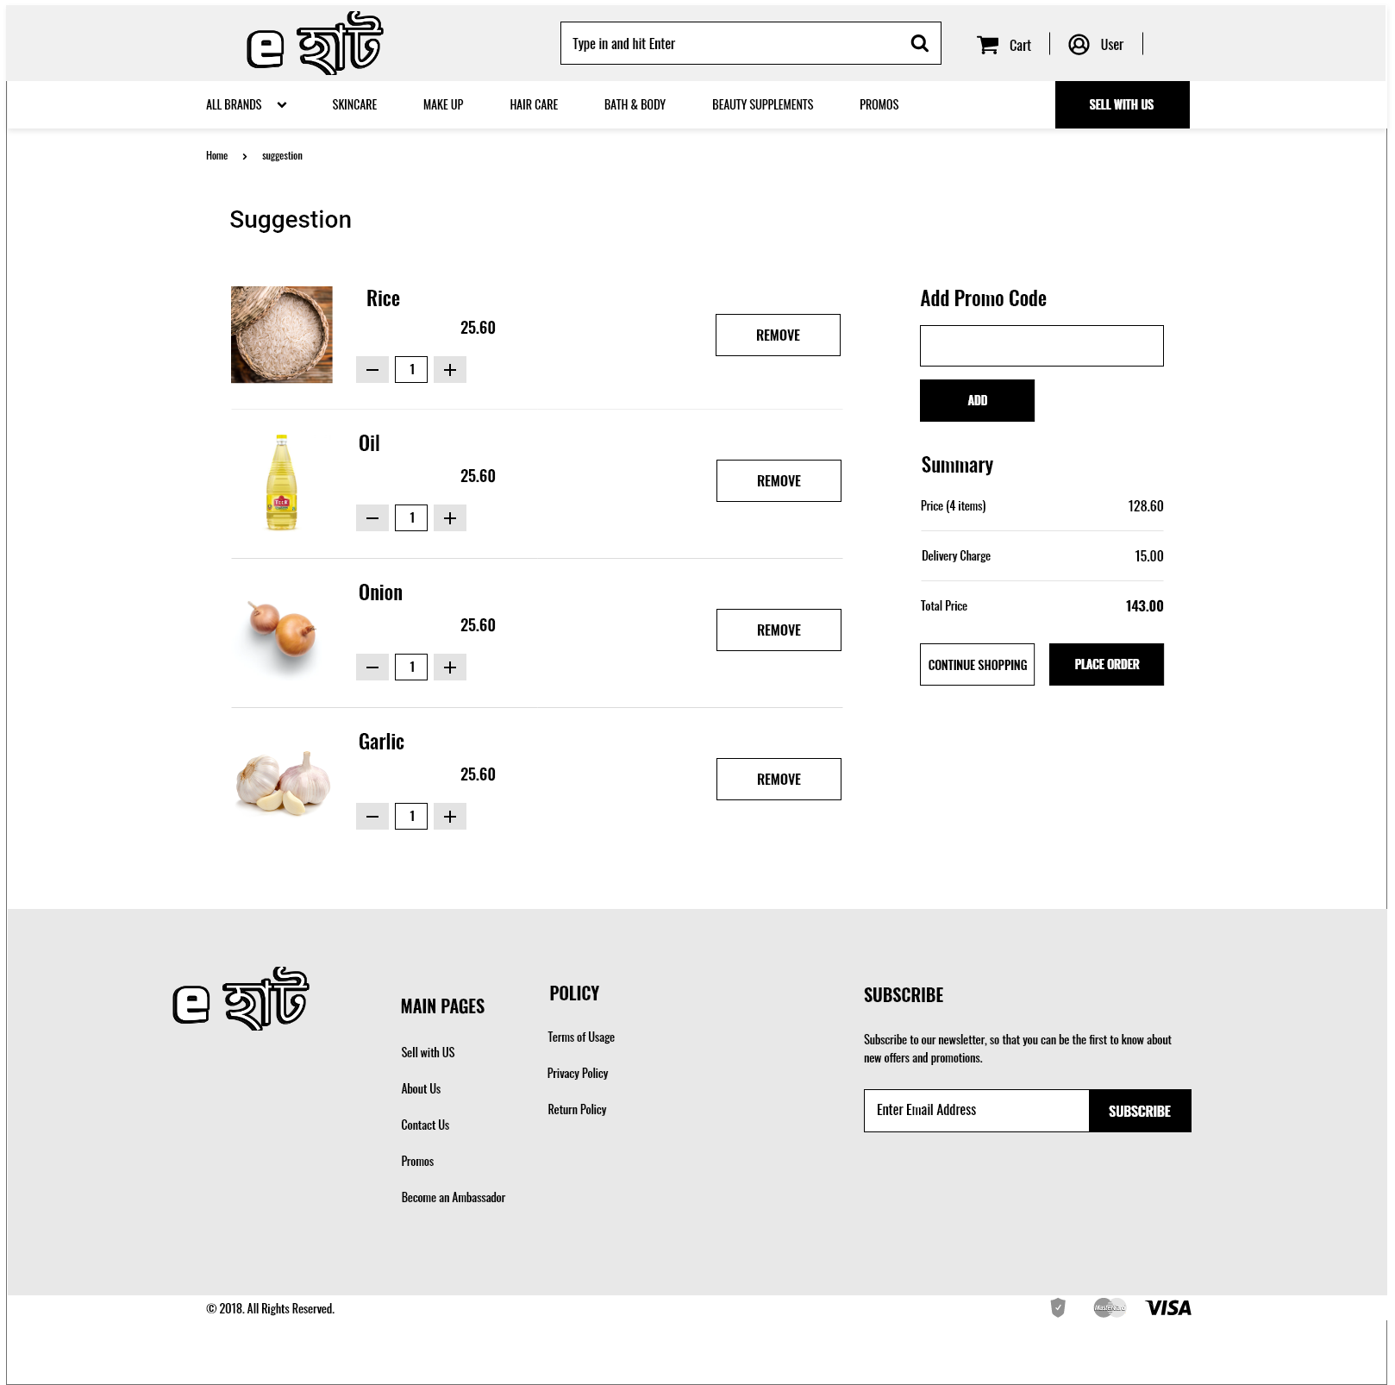

**User Registration**

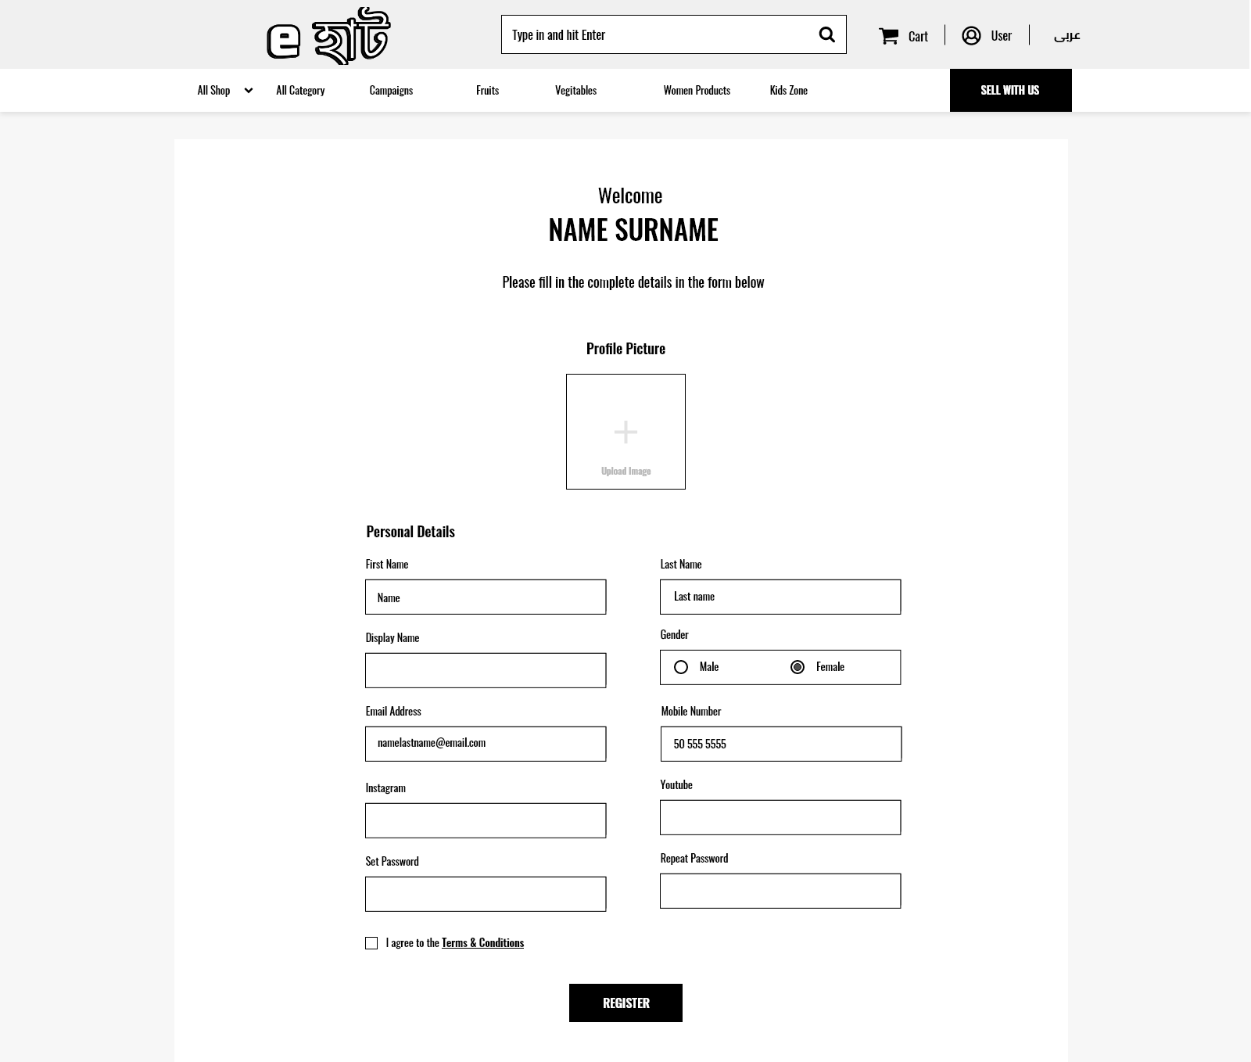

**Cart**

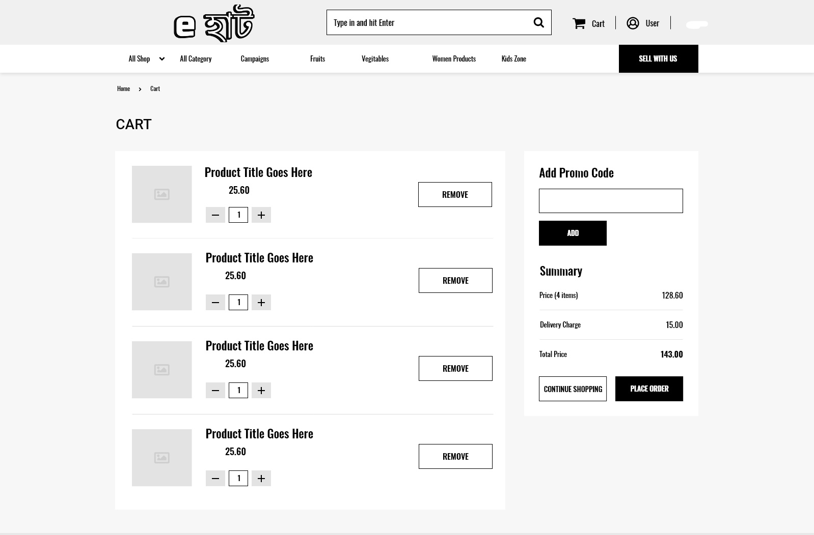

**Check out**

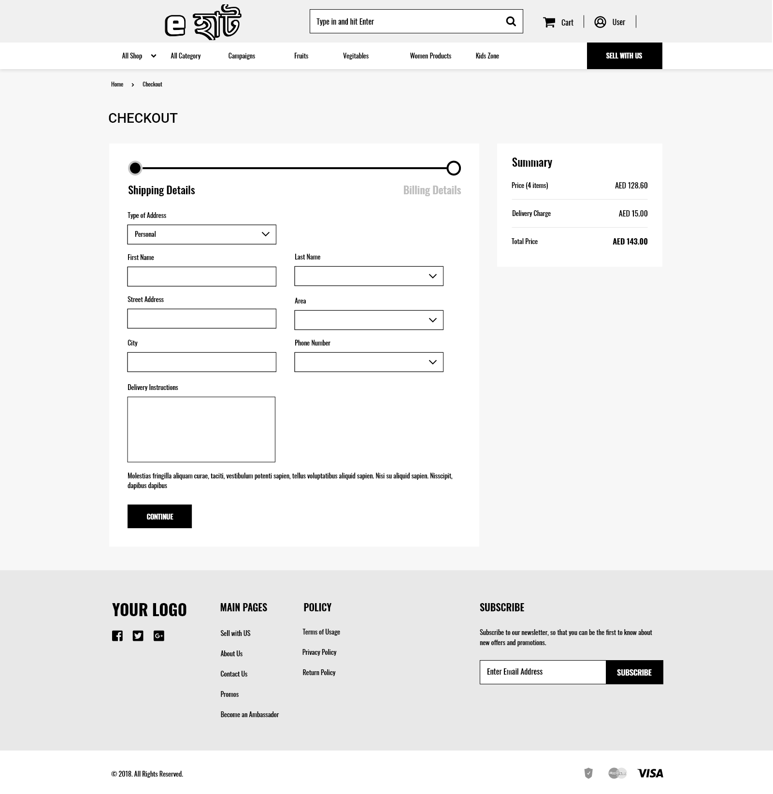

**Dash Board**

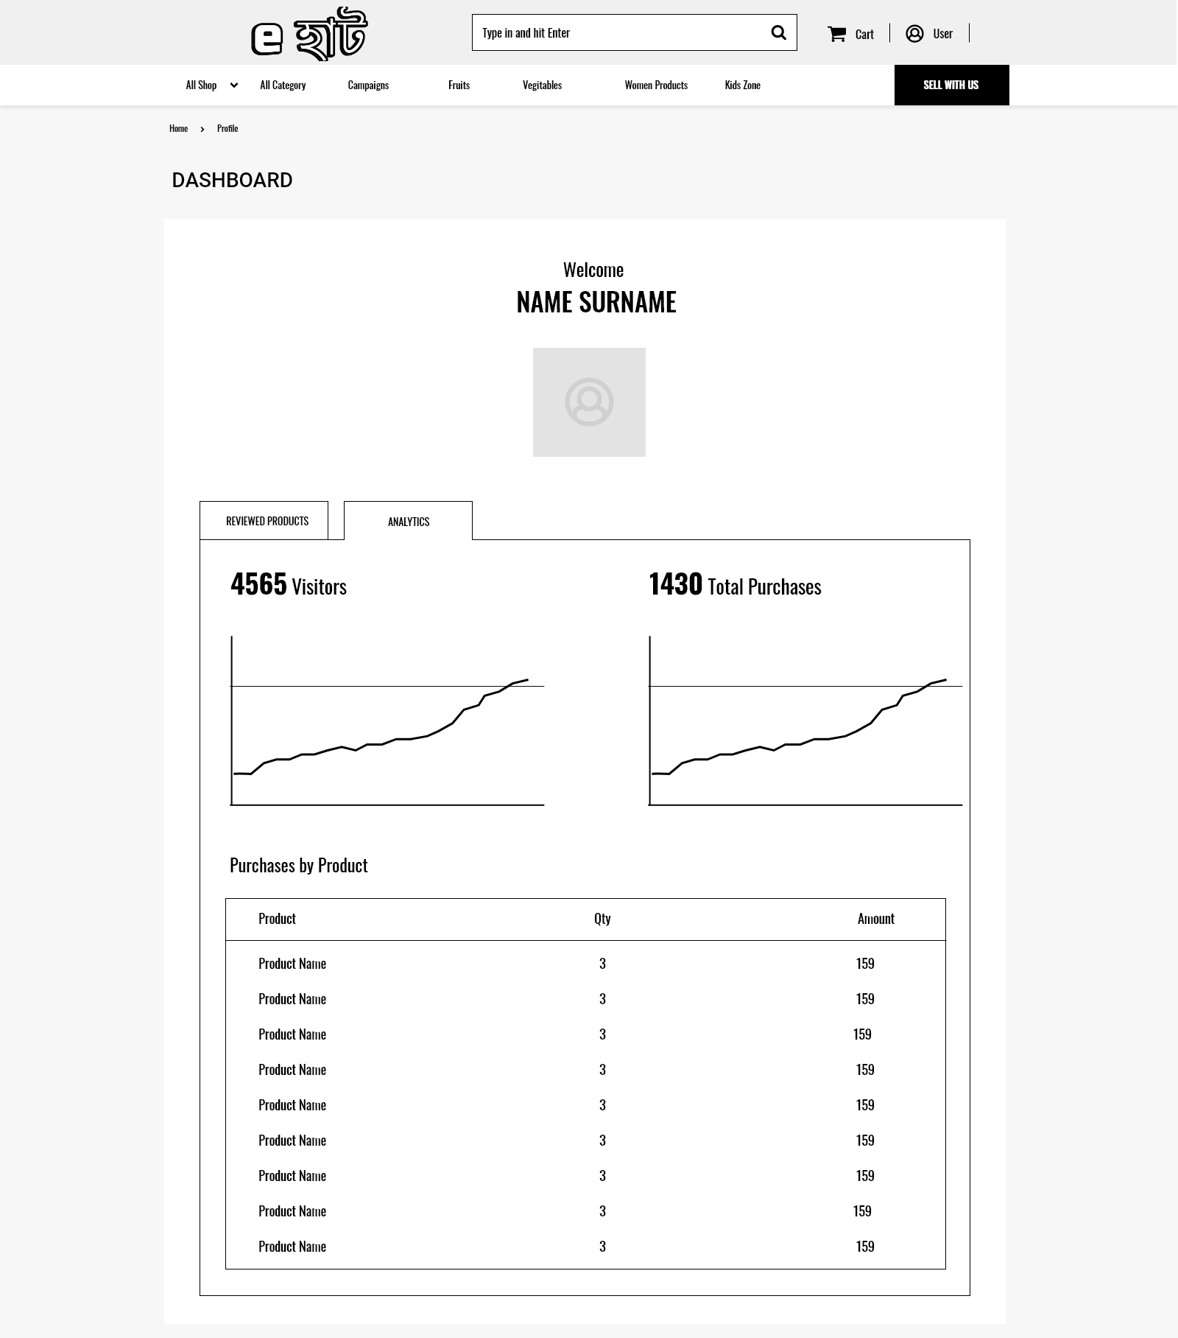

* 1. **Software interface:** ToBuild this project we have used desktop applications.

OS: Windows 10.

Windows Applications: MS word, MS excel, Trello, Adobe XD, MS SQL Server, Chrome, and Github desktop.

Web Applications: draw.io.

* 1. **Hardware interface:** Not so many hardware used in this project. We used some simple hardware like Computer, Laptop, Mobile phone, networking hardware etc. These devices are mainly used to check the feasibility the software.
  2. **Communication interface:** Facebook messenger, Discord, Phone.

1. **Quality Attributes**
   1. **Usability:**

**For users:**

Order groceries: User can order their necessary groceries in monthly basis and get their desired groceries in weekly basis.They will get vegitables/fruits 2-3 times a week.They can also get their products in desired day and time

Select Products: User can select product from their desired shop or from the generated suggestions given.They also can search products by catagory and sort them according to popularity.

Make payments: User can make payment by Mobile banking or Card.They can also check their payments and remaining balances.

Cancel service: User can cancel the entire service or for specific week/month

Give reviews: User can give reviews after the product got recieved.Good or bad for the further updatation of the project or for solving some specific problem.

Check stats: User can check their monthly expense state, what groceries they have ordered and from where.

**For Admin:**

Add other admin/managers: Admin can add new admins and managers if they want.

View information: Admin can view all the informations of the customers,retailers and delivery men.

**For other managers:**

View stats and info: They can view stats of transaction to calculate the expenditure and income of the whole business and also make future plans and actions according to the transaction stats.

**For Retailer:**

Product customization: Retailer can add new products,can update old products,can disable products if they don’t have it.

Give discounts/voucher: Retailer can offer discounts or voucher on particular products or on minimum amount of money for gathering the attentions of the customers.

Check reviews/ratings: Retailer can check user reviews and ratings for the future improvements of their products

Update information of delivery: After giving every order to the delivery man, retailer will update the delivered order info.

**For Delivery Man:**

Check and confirm nearby order: Delivery man can check order from his/her nearby places and confirm that he/she wishes to deliver.

Check reviews: Delivery man will have his individual profile, where customers can give him ratings and reviews. He/she can check it to find if any problems and act according to that. Update delivery information: After the delivery of the groceries, he/she will confirm and update the delivery info.

* 1. **Performance:**

It will provide grocery suggestion to the user by calculating their monthly expenses,family members and needs.

It will provide searching and sorting feature using which user can buy from their desired grocery shops

It will provide account management system for the users,where user can get the information of their payment ,expense,due etc.

It will provide review and rating options for the users for both retail stores and delivery men

It will provide online payment system for the users using mobile banking or card.

It will provide many offers/vouchers according to specific retail stores to the users

It will provide Admin to create a new admin/manager profile

It will provide feature to admins,managers,accountants,hrs to view stats of revenues,expenses,transactions.

It will provide feature to admins,managers to view each other’s profile information,other user’s information/profile, retailer’s information/profile, deliveryman’s information/profile

It will provide feature to retailers to update,edit,disable any product they have / haven’t

It will provide feature to retailers to create discount/voucher offers for any product

It will provide feature to retailers to check user reviews and ratings

It will provide feature to retailers to update information of delivery after every delivery.

It will provide map feature to delivery man to check delivery info near his place so that he can

accept it

It will provide feature to delivery man to confirm delivery after the product has been given to the customers door.

1. **Data Requirements**
   1. **Logical data model:**
      1. **Use Case diagram** 
         1. **Admin**

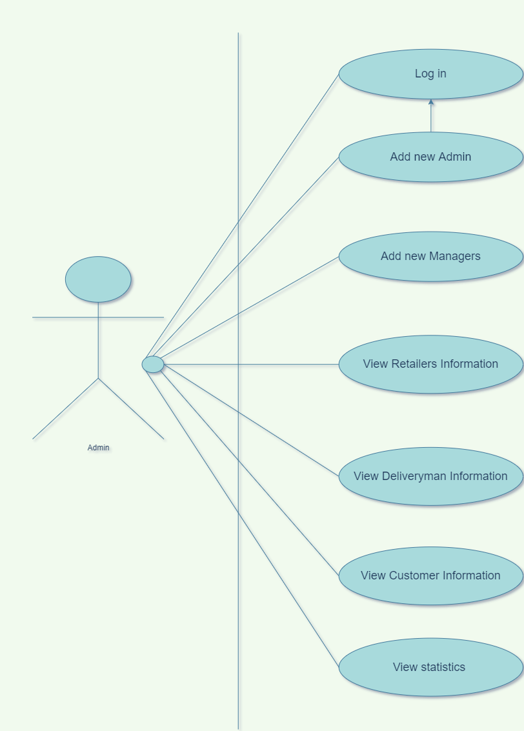

* + - 1. **Accounting and Finance Manager**

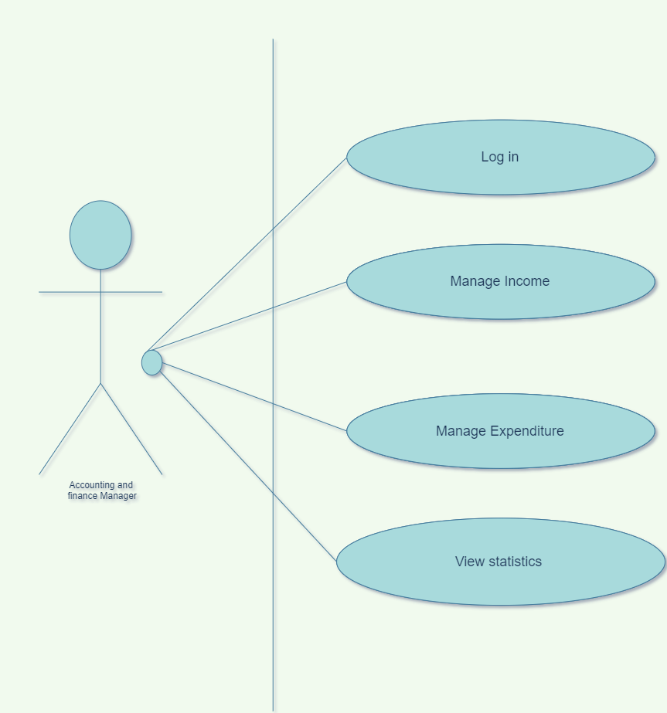

* + - 1. **HR Manager**

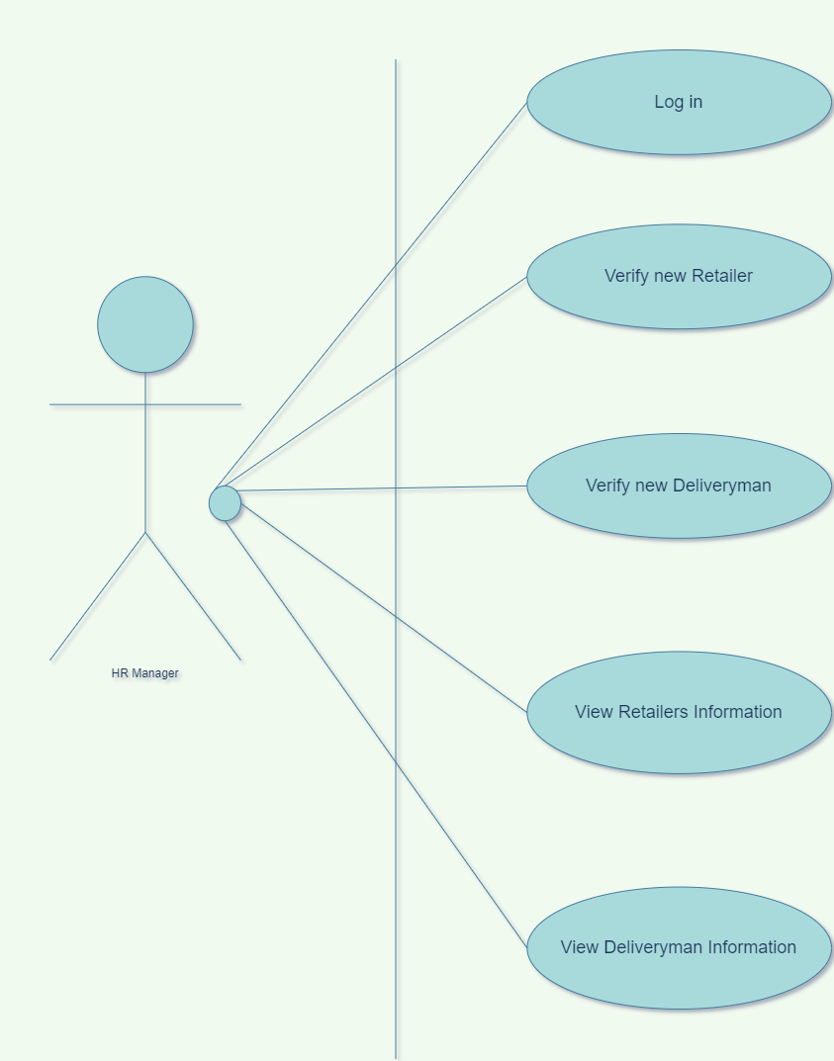

* + - 1. **Retailer**

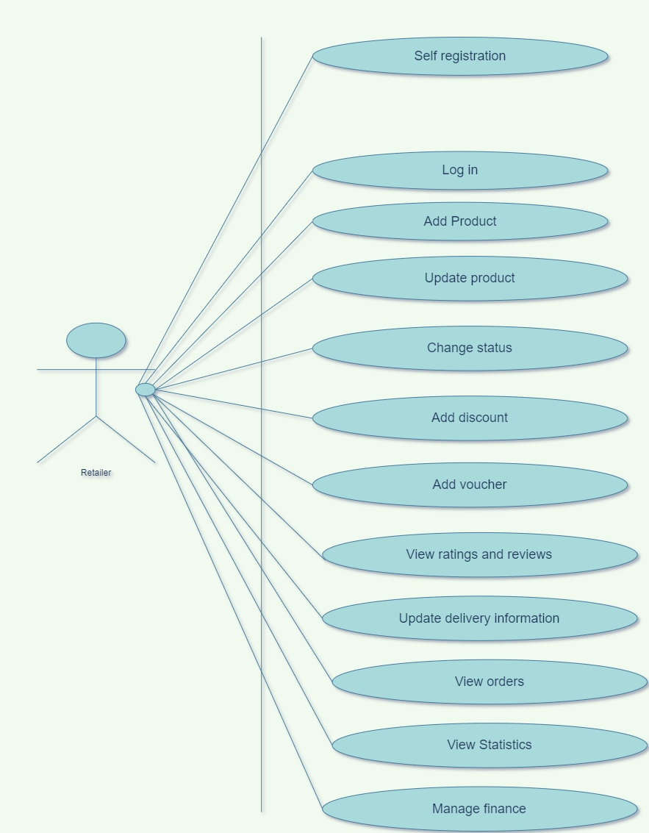

* + - 1. **Deliveryman**

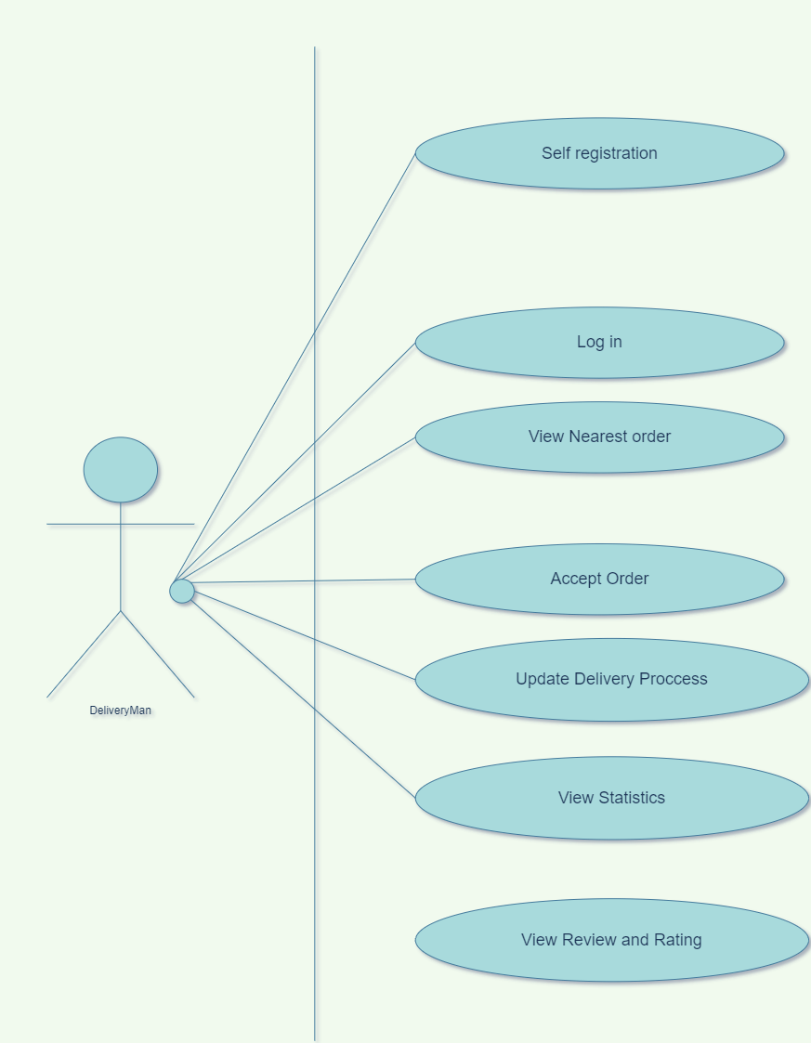

* + - 1. **Customer**

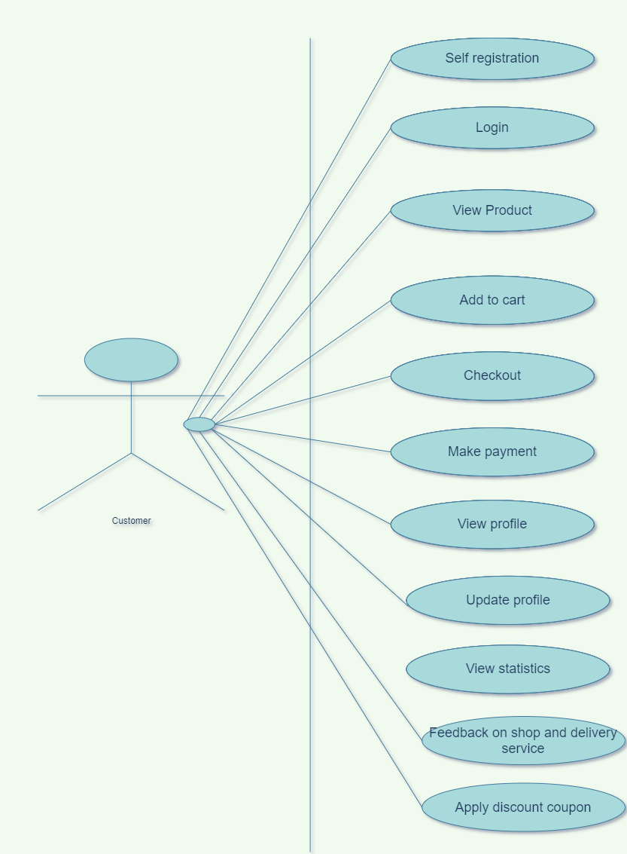

* + 1. **Activity Diagram**

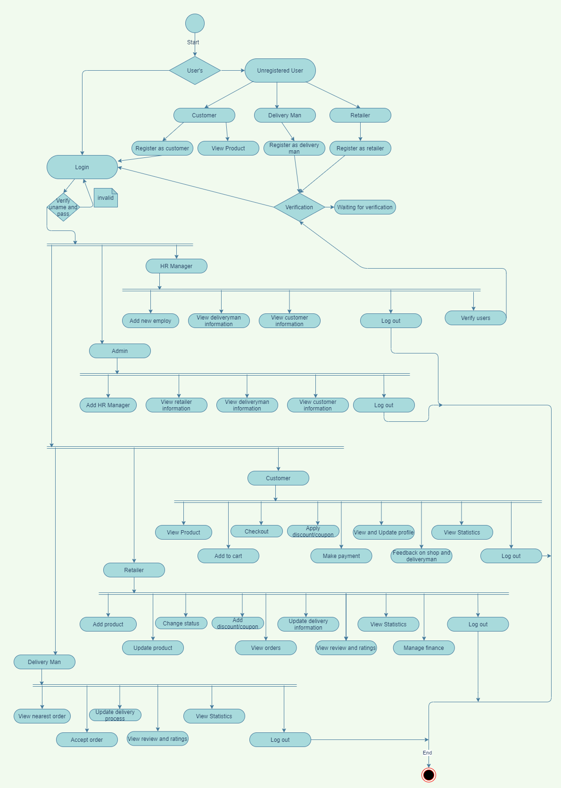

* + 1. 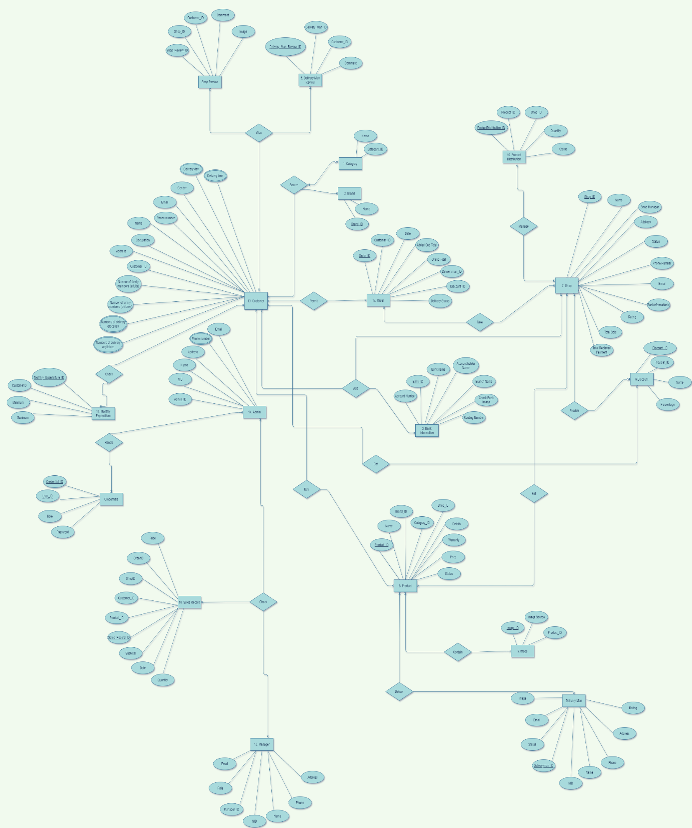**E-R Diagram**
    2. **Class Diagram**
  1. **Data dictionary –s:**